EXERCÍCIO
Considere as seguintes expressões:
A) S = (( A + B ) + (C + D))

B) S = ( A + B + C ) . ( A + B + D )
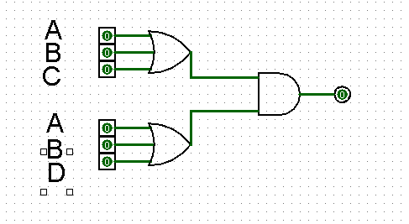

C) S = ( A + B ) . D . ( A + C ) . B
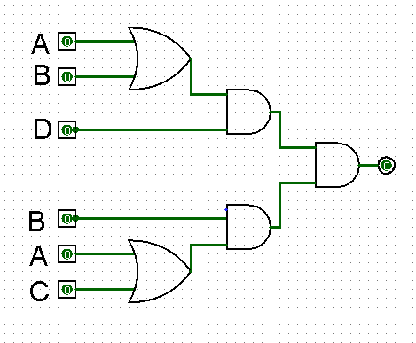

D) S = (( A + B ) . C ) + (( B . C ) . ( A + ( B . D ) ))
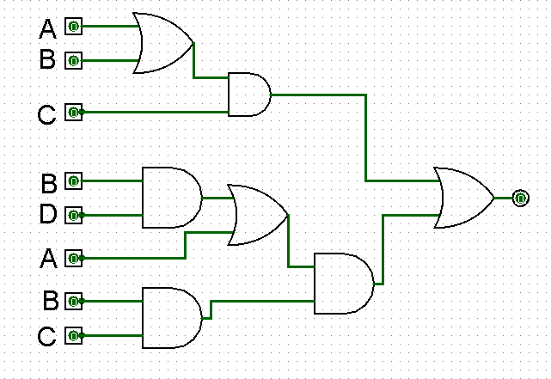

1) Desenhe o circuito correspondente as expressões
2) Construa a tabela da verdade para cada expressão

Considere as seguintes tabelas da verdade:
a)
A | B | C | D | S
0 | 0 | 0 | 0 | 0
0 | 0 | 0 | 1 | 1
0 | 0 | 1 | 0 | 1
0 | 0 | 1 | 1 | 1
0 | 1 | 0 | 0 | 1
0 | 1 | 0 | 1 | 1
0 | 1 | 1 | 0 | 1
0 | 1 | 1 | 1 | 1
1 | 0 | 0 | 0 | 1
1 | 0 | 0 | 1 | 1
1 | 0 | 1 | 0 | 1
1 | 0 | 1 | 1 | 1
1 | 1 | 0 | 0 | 1
1 | 1 | 0 | 1 | 1
1 | 1 | 1 | 0 | 1
1 | 1 | 1 | 1 | 1

B)
A | B | C | D | S
0 | 0 | 0 | 0 | 0
0 | 0 | 0 | 1 | 0
0 | 0 | 1 | 0 | 0
0 | 0 | 1 | 1 | 1
0 | 1 | 0 | 0 | 1
0 | 1 | 0 | 1 | 1
0 | 1 | 1 | 0 | 1
0 | 1 | 1 | 1 | 1
1 | 0 | 0 | 0 | 1
1 | 0 | 0 | 1 | 1
1 | 0 | 1 | 0 | 1
1 | 0 | 1 | 1 | 1
1 | 1 | 0 | 0 | 1
1 | 1 | 0 | 1 | 1
1 | 1 | 1 | 0 | 1
1 | 1 | 1 | 1 | 1

C)
A | B | C | D | S
0 | 0 | 0 | 0 | 0
0 | 0 | 0 | 1 | 0
0 | 0 | 1 | 0 | 0
0 | 0 | 1 | 1 | 0
0 | 1 | 0 | 0 | 0
0 | 1 | 0 | 1 | 0
0 | 1 | 1 | 0 | 0
0 | 1 | 1 | 1 | 1
1 | 0 | 0 | 0 | 0
1 | 0 | 0 | 1 | 1
1 | 0 | 1 | 0 | 0
1 | 0 | 1 | 1 | 1
1 | 1 | 0 | 0 | 0
1 | 1 | 0 | 1 | 1
1 | 1 | 1 | 0 | 0
1 | 1 | 1 | 1 | 1

D)
A | B | C | D | S
0 | 0 | 0 | 0 | 0
0 | 0 | 0 | 1 | 0
0 | 0 | 1 | 0 | 0
0 | 0 | 1 | 1 | 0
0 | 1 | 0 | 0 | 0
0 | 1 | 0 | 1 | 0
0 | 1 | 1 | 0 | 1
0 | 1 | 1 | 1 | 1
1 | 0 | 0 | 0 | 0
1 | 0 | 0 | 1 | 0
1 | 0 | 1 | 0 | 1
1 | 0 | 1 | 1 | 1
1 | 1 | 0 | 0 | 0
1 | 1 | 0 | 1 | 0
1 | 1 | 1 | 0 | 1
1 | 1 | 1 | 1 | 1

